**Web Assessment**

**Pre-requisites**

1. Java and maven must be installed, environment variables must be configured

**How to execute the code?**

1. Open CMD

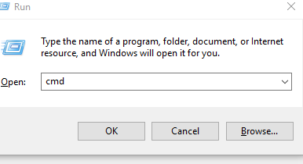

1. Change director to project directory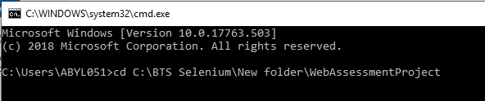
2. Type “mvn clean test” and press, enter execution should start.

**How to view report**

1. Open the project and navigate to target\surefire-reports folder



1. Open index.html

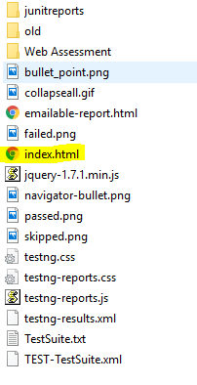

1. Under **results** they are three methods executed named AddUser which add a user and verify if user is added successfully and validateUsersTable which verify if user is on the User List Table
2. 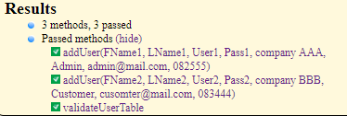
3. To view report screen evidence click **Report output** under info

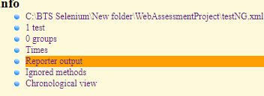

To view screenshot navigate to WebAssessmentProject\Screenshots

